# **Name: Abdurrahman Qureshi**

# **Roll no: 210451**

## **Practical no 10: -**

**CODE:**

#include <iostream>

#include <conio.h>

using namespace std;

class number{

public:

int x, y;

number(int a, int b){

x = a;

y = b;

}

void display(){

cout << "X= " << x << endl;

cout << "Y= " << y << endl;

cout << "Addition of 2 nos: " << x + y << endl;

cout << "Subtraction of 2 nos: " << x - y << endl;

cout << "Product of 2 nos: " << x * y << endl;

cout << "Division of 2 nos: " << x / y << endl;

}

~number(){

cout << "Object destroyed";

}

};

int main()

{

number o1(20, 12);

o1.display();

return 0;

}

**OUTPUT:**

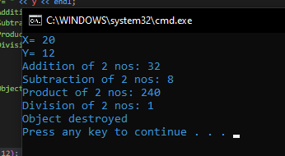

#include <iostream>

#include <conio.h>

using namespace std;

class product

{

public:

int p_id, p_price;

char *p_name;

product()

{

p_id = 0;

p_price = 0;

p_name = " ";

}

product(int a, int b, char *c)

{

p_id = a;

p_price = b;

p_name = c;

}

void putdata()

{

cout << "Product ID:" << p_id << endl;

cout << "Product Price:" << p_price << endl;

cout << "Product Name:" << p_name << endl;

}

};

int main()

{

int a, b, i;

char *c;

for (i = 0; i < 3; i++)

{

cout << "Enter details of the product:\n";

cin >> a >> b >> c;

product p1(a, b, c);

p1.putdata();

}

return 0;

}

**OUTPUT:**

